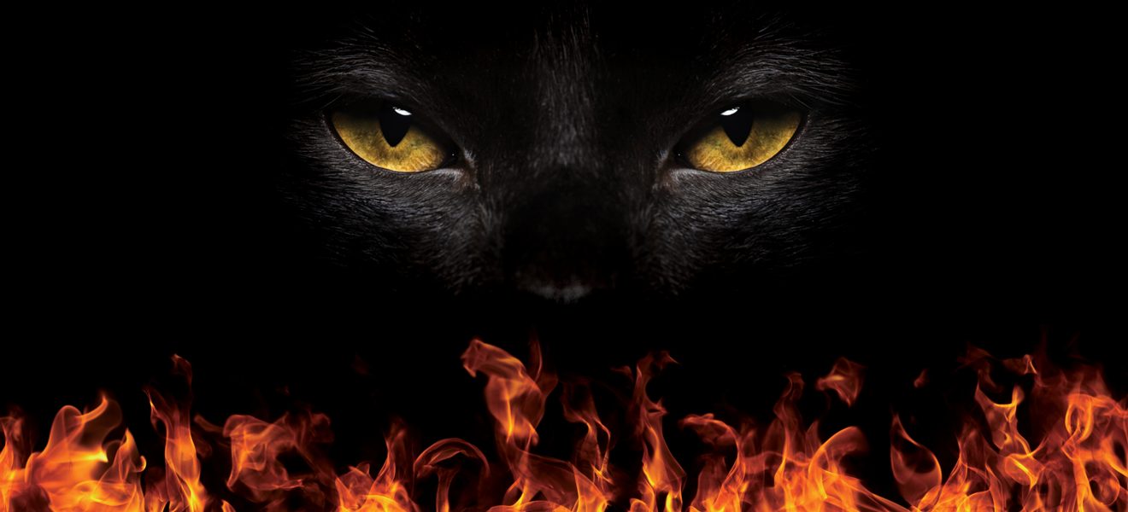

FREQUENTLY ASKED QUESTIONS
Read on for FAQs answered here by Blaze, our Firewalking experts!
What happens on the night? Once you have registered and everyone is ready, you will undergo a training session in a private room away from family and friends. Everyone must take part in this training, it’s the best part, and the firewalk is a bonus!

The training is based around proven motivational and psychological methods. It doesn’t involve any elements of hypnosis, spiritual training, chanting, ‘brainwashing’, voodoo or any similar methodologies. It’s great fun!

The Instructor is a world class authorised Blaze ’Fire Master’ Instructor who has undergone a minimum of 200 separate firewalking events at different locations at different times of the year and with varying weather conditions as part of the fire team before being invited to train as a Blaze Instructor.

I’m bringing friends/family to watch, is that ok? Friends and family are encouraged to come along and support you and the other walkers. We know that you’ll want them to take lots of photographs and video of your firewalk. Food and drinks will be available to purchase on the night and there will be live music too!

We’re sorry but friends and family won’t be allowed to watch the training.

Are there age limits? The minimum age is 14 years of age; parental consent is required for 14-15 year olds. There is no upper age limit.

Can my friends and family take part in the Firewalk? Please make sure those of your friends and family who would like to take part in the Firewalk sign up as soon as possible here; www.cats.org.uk/support-us/events/challenge-events/adrenaline-challenges-zipwires-firewalks-and-abseils

Does it hurt? Everyone’s firewalking experience is unique. There are very obvious physical reasons why firewalking is possible. These will be explained during the training. We’ll also tell you about firewalking myths…. there lots of them. The hardest thing to overcome is the fear of taking the first step as it is a new experience!

What does it feel like? A number of people don’t remember having any physical sensation at all about the experience. Some say it was cold, some say it was warm. Our favourite was that it felt ‘fluffy’

Is it real fire? Yes, burning at an average temperature of 1236 degrees Fahrenheit! To put it into perspective: paper combusts at 451 degrees Fahrenheit, aluminium melts at 1100 degrees Fahrenheit!

What do you burn? We burn wood, which is broken down into a smooth path of embers 20’ long by 2’ wide.

Do I have to run? Not at all, running pushes your feet deeper into the embers. A quick walking pace is sufficient. You’ll be shown the correct pace in the training.

What happens if it rains? We get wet. Provisions are made for all types of weather conditions and if the wood is kept dry prior to lighting, the event will go ahead.

Do I actually walk on a flaming fire? No, you walk on the fire bed itself, by the time you come out of the training seminar the fire will have burnt down to embers. If there are any flames they will be down the sides of the fire lane.

What happens if I stop halfway through? Don’t worry, you won’t! There will be someone walking beside you. We all need help and support at some points of our lives, we’ll support you on your firewalk.

What’s the best thing to wear on the night? There are no special requirements regarding clothing. Casual clothing is best and something that you are not bothered if it goes up in flames! Just kidding, all you need to do is roll up the bottom of your trousers to they don’t get dirty. Tights and stockings would need to be removed before the walk itself. Your feet are going to be sooty afterwards. This is the best time to wear those odd socks we all have lingering in our sock drawer.

Please wait until after the firewalk to have your pedicure. Don’t use oil based creams and/or foot sprays on the day of the firewalk.

Wear light coloured clothing as this shows up better in photographs and videos. Blaze team wear black clothing to blend into the background of photographs and videos. We want you to stand out not us.

I’m worried about covid? We will ask everyone to be respectful of each other’s personal space and be supportive of anyone who decides to wear a facemask when doing the indoor training.

I have a medical condition; will I be able to firewalk? We do everything we can to be as inclusive as possible. If you need support when walking on the firewalk that is what we are here for. One of the Blaze team walks beside every firewalker. We can have someone on either side if you wish. If we need to adapt the firewalk to enable you to take part, we can talk about all the options there are. We’ve had people taking part in our firewalks that were often told they wouldn’t be able to take part in activities.

Give Blaze a call on either 0115 840 4329 or 07712 048042 and ask to speak to Karen as she was a registered nurse for over 20 years, she will be able to talk to you about taking part in the firewalk. All calls and correspondence will be treated in the strictest confidence. We all need help and support at times in our lives, we’ll support you every step of the way during your firewalk.

I’m pregnant, can I take part? Congratulations! All that we will be physically doing in the training is standing up, sitting down and practising the correct pace to walk when firewalking. If you are physically well, your blood pressure is stable, and you can still see your feet when standing up, you will be able to firewalk.

Can I have an alcoholic drink for some Dutch courage? No, you won’t be allowed to take part if you have consumed alcohol or taken recreational drugs. It’s only for a couple of hours and that glass of wine or beer tastes so much better afterwards. You know that nothing good ever happens following the words “Here, hold my beer, watch this.”

We want you to have fun and enjoy this experience. However, for the safety of all participants, Blaze and Cats Protection reserve the right to refuse to allow you to participate if you do not attend the training or have consumed alcohol prior to attending the event.

Please note we do not offer refunds.

